Tab 1

**Chapter 3 - Dynamics I**

**All Lectures Uploaded on Youtube:**

[**https://tinyurl.com/fkm9-physics**](https://tinyurl.com/fkm9-physics)



**Force:** A vector quantity that causes or tends to cause a change in the state of motion of a body.  
Can **start, stop, speed up, slow down** or **change the direction** of motion.

*Forces are broadly classified into:*1. Contact Forces  
2. Non-contact Forces

**Contact Forces**

It occurs **only when two objects are in physical contact**.  
E.g. A cricket bat hitting a ball, a book lying on a table.

*Types of Contact Forces:*

1. **Normal Contact Force:**A force **perpendicular to the surface** of contact. It prevents objects from passing through each other.  
   Example: Table exerts a normal force on a book lying on it.
2. **Thrust Force:** It acts in the **direction of motion**. It is used to **accelerate** objects.  
   Example: Force that propels a flying machine forward.
3. **Frictional Force:**It opposes **relative motion** or the **tendency of motion** between surfaces in contact. It depends on:  
   -> Nature of the surfaces.  
   -> The force pressing them together.  
   Friction is present between two solid surfaces, but is also called **Air Resistance/Drag** when it opposes motion through a fluid like air or water.
4. **Tension:** Forces exerted by two or more physical objects that are in contact, such as through a string, rope, cable, or spring, is called tension.
5. **Elastic force**: A force that resists change in shape, present when objects like springs or rubber bands are stretched.This force is present in a stretched string, rope, or cable, where equal and opposite forces are applied at both ends.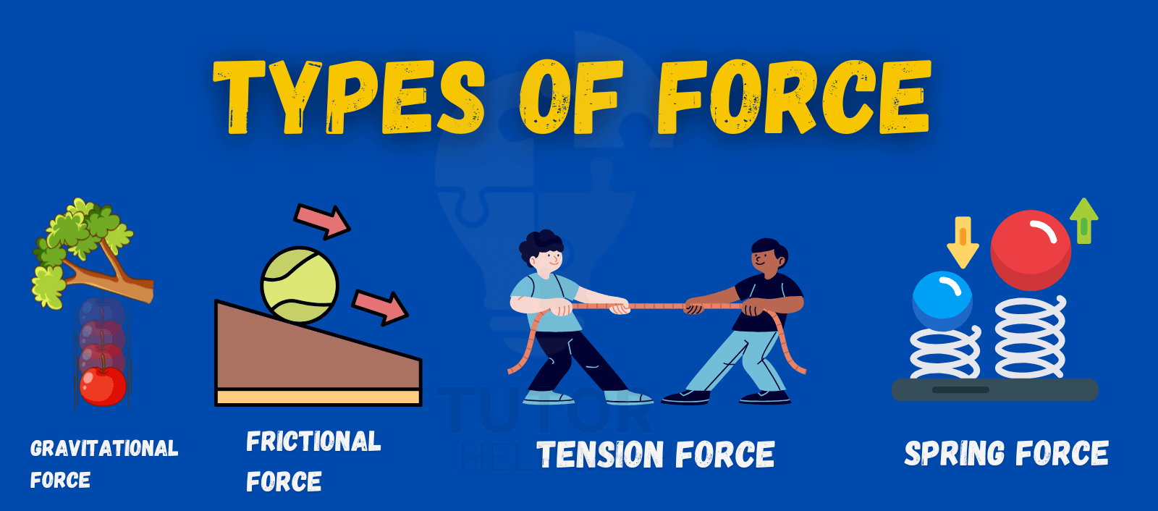

## 

## 

## **Non-Contact Forces**

Forces that act at a distance, without physical contact between objects are called **Non-contact Forces.**  
Examples: Magnetic force, gravitational force, electrostatic force.

1. **Magnetic Force**: Attractive or repulsive force between magnets or magnetic materials (e.g., repulsive force between two north poles)
2. **Electrostatic Force**: Attractive or repulsive force between charged objects (e.g., force between positively and negatively charged electrons).
3. **Gravitational Force**: Attractive force between two objects with mass, such as the force that keeps planets in orbit around the sun, or an apple falling to Earth.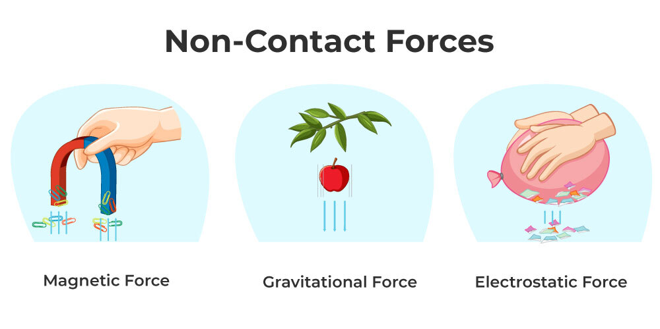

## 

## 

## 

## 

## 

## 

## 

## 

## 

## **Fundamental Forces in Nature**

All forces in nature can be categorized into four fundamental types:

* **Gravitational Force**: The weakest, but has infinite range. It attracts all objects with mass toward each other. It is responsible for the structure and motion of celestial bodies (e.g., planets, stars, galaxies).
* **Electromagnetic Force**: It includes both electric and magnetic forces and is responsible for the interaction between charged particles.
* **Strong Nuclear Force**: The strongest force, but acts over a very short range. It binds protons and neutrons together in the nucleus of an atom.
* **Weak Nuclear Force**: It is responsible for certain types of radioactive decay (beta decay). It is weaker than both the strong nuclear force and electromagnetic force but stronger than gravity. It acts at a very short range inside atomic nuclei.

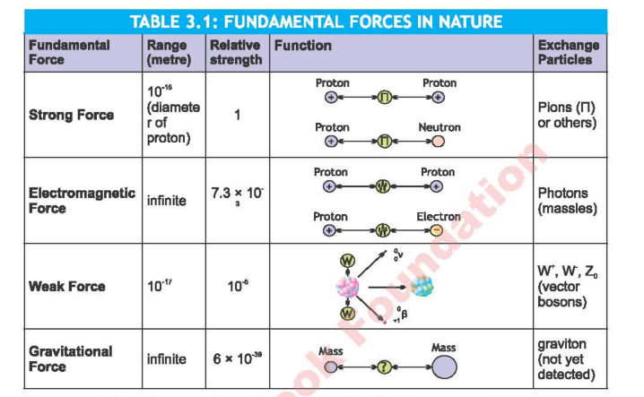

***Force Diagrams***

Force diagrams help visualize forces and their effects.There are two types of force diagrams: **system diagrams** and **free-body diagrams**.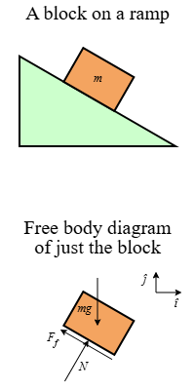

1. *System Diagrams:* A system diagram shows all the objects present in the system.
2. *Free-body diagram:* It shows a single object, isolated from its surroundings, with all forces acting on it drawn as arrows showing magnitude and direction.

* Arrows that are labelled with "F" and subscript (e.g., Fg for gravity) indicate force type and direction.

**Net Force:**

Net force affects an object and is the net effect of all forces acting on it. It is calculated by adding all forces acting on the object.

- If the net force = 0 N, forces are balanced, and there will be no change in the object’s motion.

* *Free-Body Diagrams and Resultant (Net) Forces*

- To study the effects of forces acting on an object, we apply the skill of drawing force diagrams.

- **Resultant force:** A resultant force is a single force that has the same effect as the combined effect of all the forces to be added.

It is the net force that can also be called the net effect; the two terms can be used interchangeably.

*- Resultant force can be obtained by simple addition of forces (Fnet).*

- Forces are vector quantities which require both magnitude with proper unit as well as direction for its complete description. Therefore it is required that we should draw the forces to a common scale as vectors (arrow diagrams).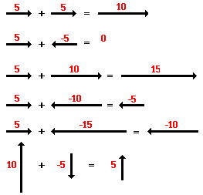

- Simply add the magnitudes of vectors in case of parallel forces and subtract the magnitudes of vectors in case of unlike parallel forces.

- Vectors can be drawn on a *coordinate axis*, and then vectors to the same scale can be added using the head-to-tail rule of vector addition.

**Newton's First Law of Motion (Law of Inertia):**

*An object at rest stays at rest, and an object in motion stays in motion with a constant velocity, unless acted upon by a net external force.*

E.g. A book on a table remains stationary unless pushed.

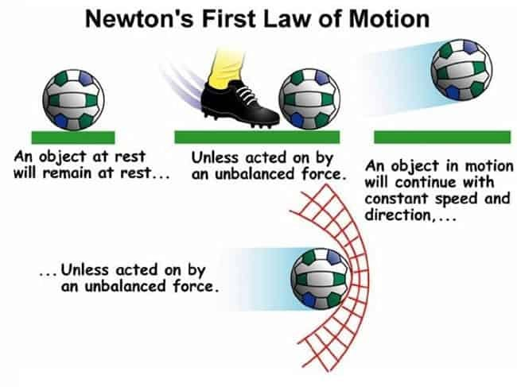

* The natural tendency of an object to remain in a state of rest or motion is termed as ***Inertia.***
* The greater the mass of the object, the greater the inertia experienced.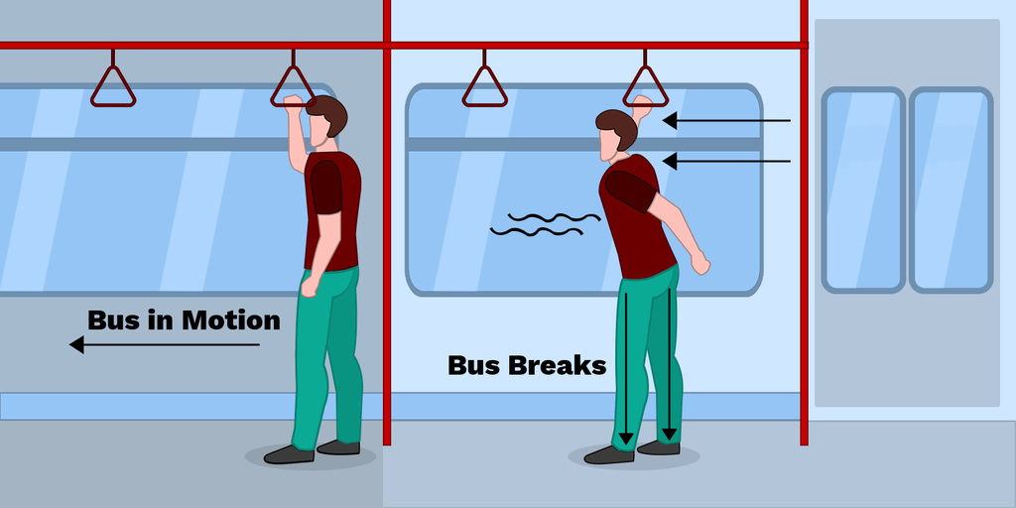

**Newton's Second Law of Motion:**

*The acceleration of an object as produced by a net force is directly proportional to the magnitude of the net force, in the same direction as the net force and inversely proportional to the mass of the object.*

$acceleration= \frac{netforce}{mass}$

E.g. Pushing a car requires more force than pushing a bicycle due to the car's greater mass.

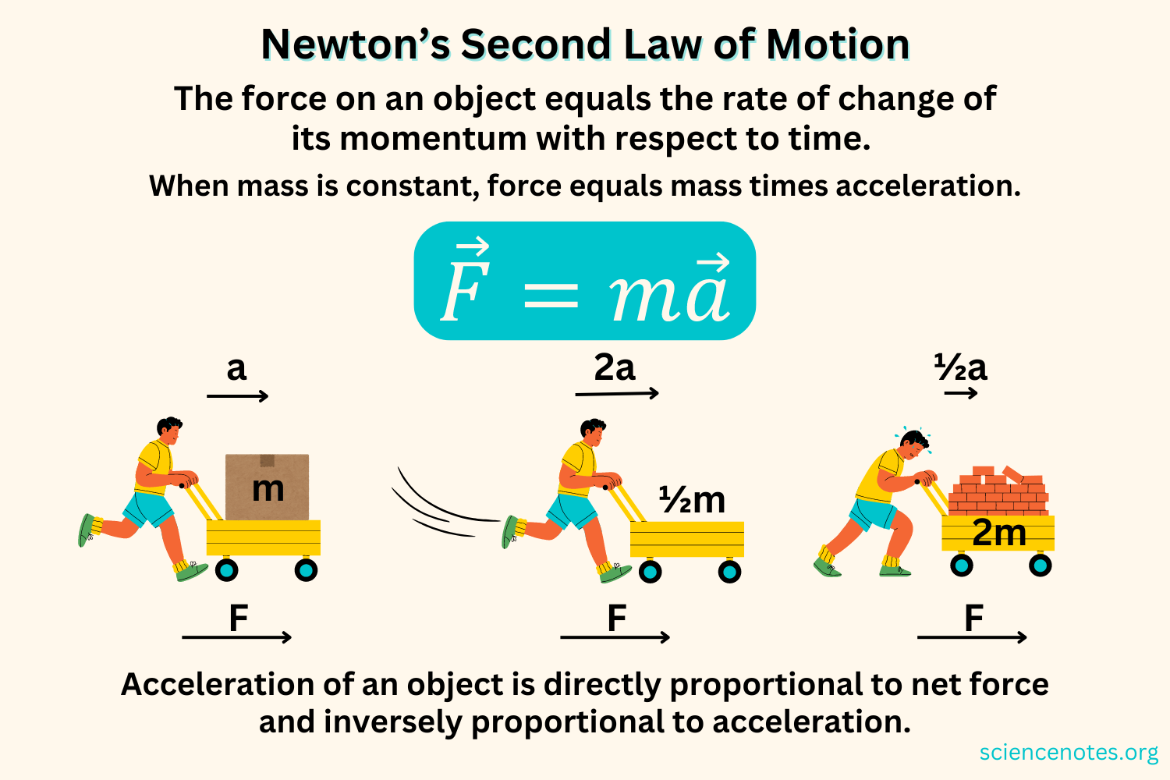

*The SI Unit of Force is Newton (N)*

**Newton's Third Law of Motion (Law of Action-Reaction):**

*For every action, there is an equal and opposite reaction.*

E.g. A rocket propels upward as gases are expelled downward with equal force.

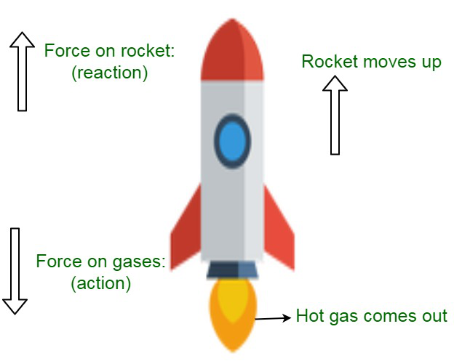

*Limitations of Newton's Laws*

- It is inapplicable at very high speeds (close to the speed of light), where Einstein's theory of relativity is required.

- It is not valid at atomic or subatomic scales, where quantum mechanics governs behavior.

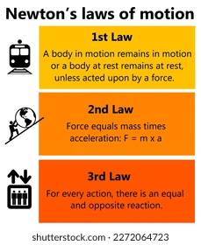

**Difference Between Weight and Mass**

- **Mass** is the amount of matter in an object, measured in *kilograms (kg)*, and remains constant regardless of location.

- **Weight** is the force exerted by gravity on an object, measured in *newtons (N)*, and varies with gravitational acceleration (e.g., different on each planet).

* Calculating Mass on Other Planets:

Mass can be calculated using the formula:

*Mass = Weight / Gravitational Acceleration*



-> Measure the weight of an object on the planet (using a scale calibrated for local gravity) and divide by the planet's gravitational acceleration (e.g., 3.7 m/s² on Mars, 9.8 m/s² on Earth).

***Gravitational Field:***

A gravitational field is a region around a mass where another mass experiences a force of attraction.

- The strength of the field is determined by the mass creating it and the distance from that mass.

***Gravitational Field Strength:***

The gravitational field strength is the amount of force acting per unit mass acting on objects in the gravitational field.

*g=Fg /m*

*The gravitational field strength is a vector quantity with a magnitude of ‘g’ that points in the direction of the gravitational force.*

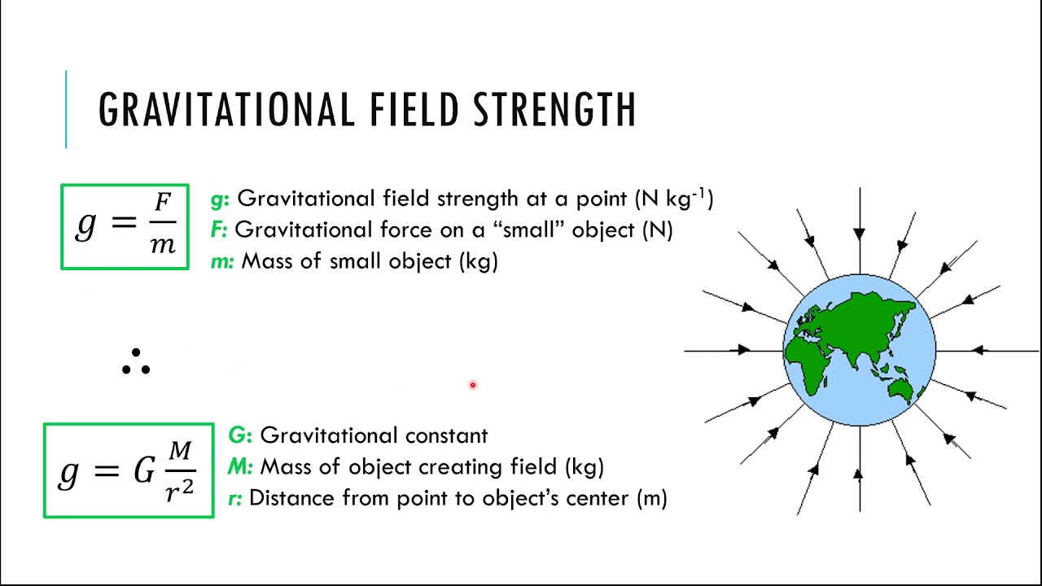

* The SI unit of gravitational field strength is measured in

*N/kg - Newtons per Kilogram.*

* Gravitational force decreases as we move away from the object exerting the force.

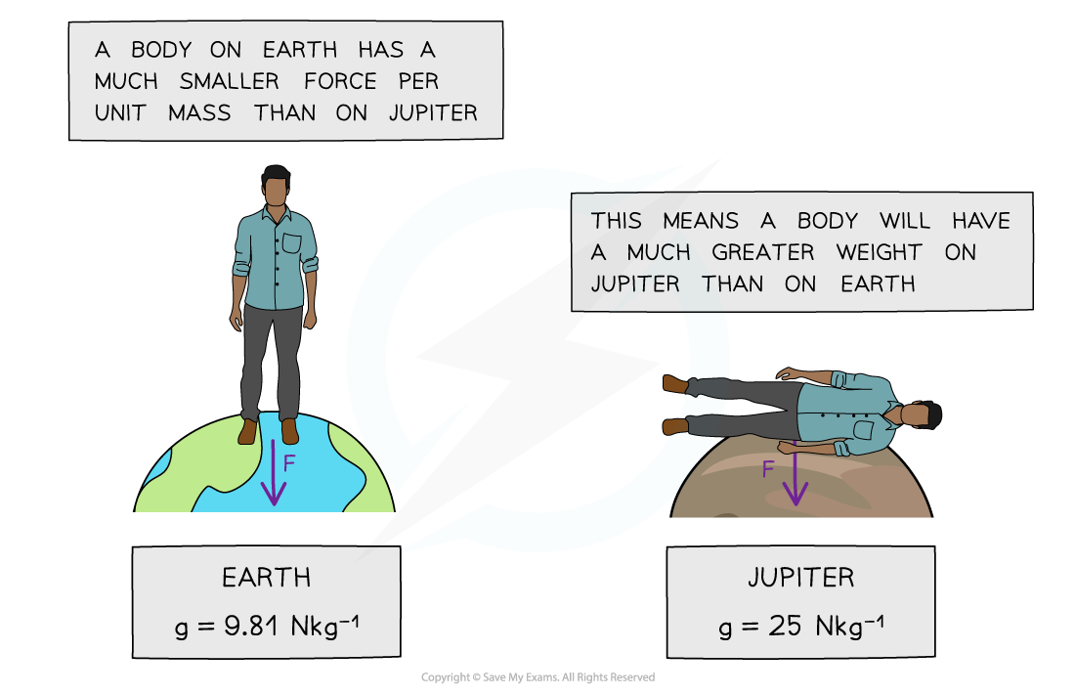

**Momentum**

- Momentum is the product of an object's mass and velocity.

*p = mv*

It is measured in **kilogram-meter per second, kgm/s,** or **Newton seconds, Ns.**

- It represents the quantity of motion an object has.

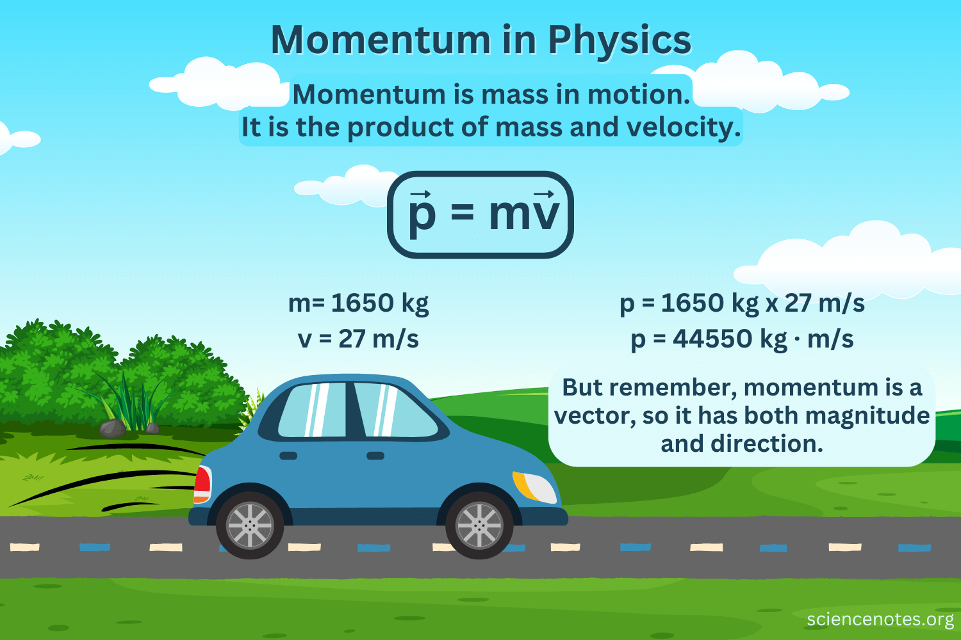

*Change of Momentum*

- Change in momentum occurs when a force acts on an object over time, calculated as Δp = m·(vf - vi), where vf is final velocity and vi is initial velocity.

- It is equal to the impulse applied.

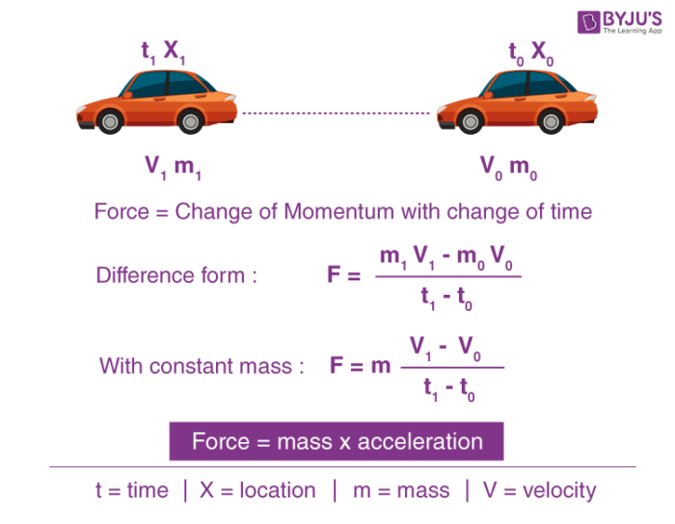

**Impulse**

- Impulse is the change in momentum, given by **ΔP= FΔt**, where F is the force and Δt is the time interval over which the force acts, measured in Ns.

- It explains how force applied over time affects an object's motion.

**Conservation of Momentum**

*The momentum of an isolated system remains constant.*

**(m₁u₁ + m₂u₂ = m₁v₁ + m₂v₂)**

* Hence, if there is no external force applied to the system, the initial momentum is equal to the final momentum
* This principle applies to collisions and explosions.
* 